Fbxl10/Kdm2b Recruits Polycomb Repressive Complex 1 to CpG Islands and Regulates H2A Ubiquitylation
- Xudong Wu^{1, 2},
- Jens Vilstrup Johansen^{1, 3},
- Kristian Helin^{1, 2,}

Summary
Polycomb repressive complex 1 (PRC1) catalyzes lysine 119 monoubiquitylation on H2A (H2AK119ub1) and regulates pluripotency in embryonic stem cells (ESCs). However, the mechanisms controlling the binding of PRC1 to genomic sites and its catalytic activity are poorly understood. Here, we show that Fbxl10 interacts with Ring1B and Nspc1, forming a noncanonical PRC1 that is required for H2AK119ub1 in mouse ESCs. Genome-wide analyses reveal that Fbxl10 preferentially binds to CpG islands and colocalizes with Ring1B on Polycomb target genes. Notably, Fbxl10 depletion causes a decrease in Ring1B binding to target genes and a major loss of H2AK119ub1. Furthermore, genetic analyses demonstrate that Fbxl10 DNA binding capability and integration into PRC1 are required for H2AK119 ubiquitylation. ESCs lacking Fbxl10, like previously characterized Polycomb mutants, cannot differentiate properly. These results demonstrate that Fbxl10 has a key role in regulating Ring1B recruitment to its target genes and H2AK119 ubiquitylation in ESCs.

Graphical Abstract
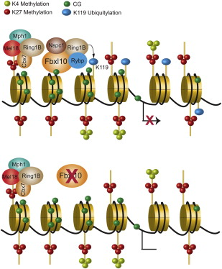

Highlights
► Fbxl10 binds to most CpG islands in ESCs ► Fbxl10 recruits Nspc1 and Ring1B to CpG islands ► The Fbxl10, Nspc1, and Ring1B complex is required for H2A monoubiquitylation ► Fbxl10 is required for proper ESC differentiation

Figures and tables from this article:
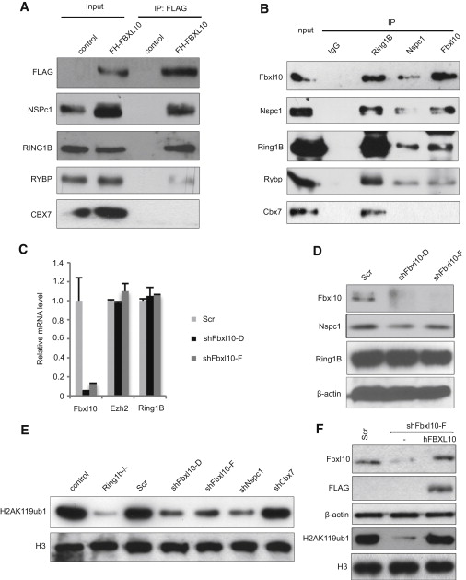
Figure 1. Fbxl10 Forms a Noncanonical PRC1 Complex, which Is Essential for Global Levels of H2AK119ub1 in ESCs(A) Anti-FLAG IP of FH-FBXL10 ectopically expressed in 293FT cells, followed by WB using antibodies for the indicated proteins.(B) CoIP of endogenous Fbxl10, Ring1B, and Nspc1 proteins in E14. For (A) and (B), the input lanes contain 5% of the amount used for IP. The Fbxl10 rabbit polyclonal antibody was used for the IP, whereas mouse monoclonal antibody was used for the WB.(C) Real-time qPCR analyses for determining the relative mRNA levels of Fbxl10, Ezh2, and Ring1B in Fbxl10-depleted E14 cells using two different shRNA constructs specific for Fbxl10 (shFbxl10-D and shFbxl10-F) and scrambled control (Scr). The error bars denote SD; n = 2.(D–F) WB analysis of protein lysates and acid-extracted histones prepared from mouse ESCs using antibodies specific for the indicated proteins. β-actin served as a loading control for total protein. H3 served as a loading control for histones. See also Figures S1 and S2.
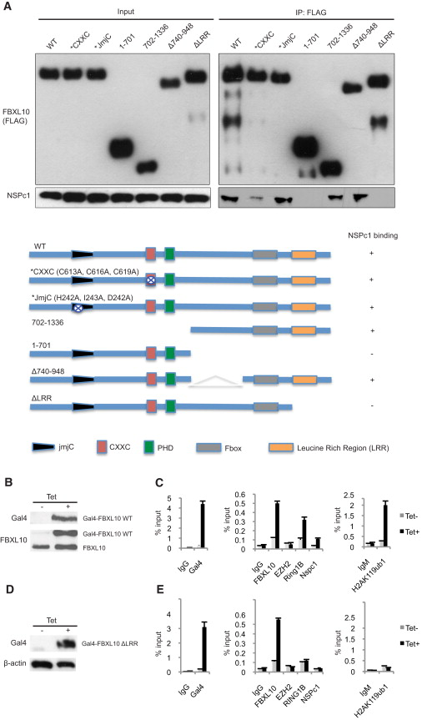
Figure 2. FBXL10 Recruits RING1B and NSPc1 to Promoters and Promotes H2AK119ub1 Dependent on its C-Terminal Region(A) Anti-FLAG IP of FLAG-HA-tagged WT and mutant FBXL10 proteins expressed in 293FT cells. Left panel: 5% of the lysate used for the IP was loaded in each lane. Right panel: Immunoprecipitated material was loaded. Schematic representation of the different FBXL10 mutants, highlighting that a short deletion of the C terminus (ΔLRR) affects the interaction with Nspc1.(B and D) WB analysis of 293T cells containing an integrated Gal4-luciferase reporter construct and expressing Gal4-FBXL10 WT (B) or ΔLRR (D) fusions dependent on the presence of tetracycline (Tet). The indicated antibodies were used.(C and E) ChIP-qPCR analyses were performed in mock (Tet−) or tetracycline-treated (Tet+) cells. Immunoglobulin G or M (IgG or IgM) antibody was used as a negative control. Primers specific for the TSS of the luciferase gene were used. The error bars denote SD; n = 2.
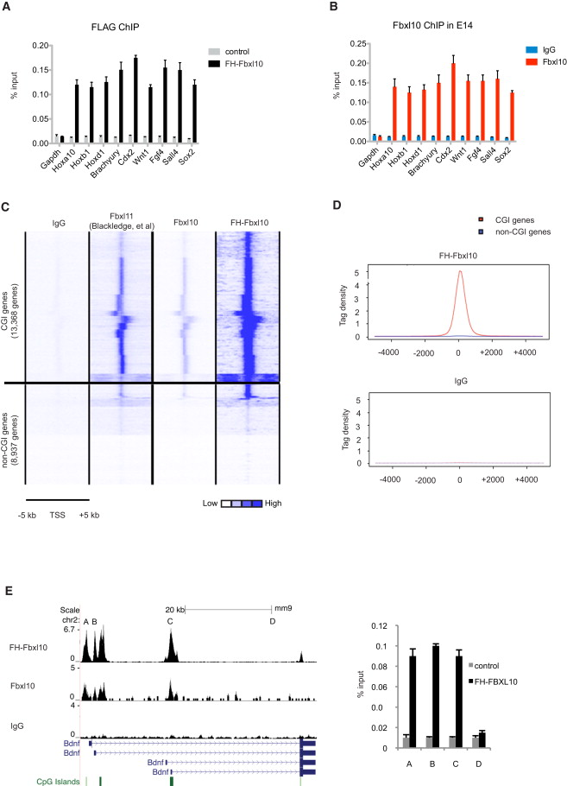
Figure 3. Fbxl10 Binds to CpG Islands(A) FLAG ChIP-qPCR analyses in FH-Fbxl10 expressing ESCs. The parental ESCs were used as a negative control.(B) Fbxl10 ChIP-qPCR analyses in E14 cells with IgG antibody as a negative control. For (A) and (B), TSSs of six repressive genes and three actively transcribed genes were detected. Gapdh promoter (not TSS) served as a negative control.(C) Heatmap showing IgG, Fbxl11, Fbxl10, and FH-Fbxl10 occupancy ± 5 kb around the TSSs of both CGI genes and non-CGI genes. The same color scales (white, no enrichment; blue, high enrichment) were used for all data sets.(D) Average FH-Fbxl10 and IgG tag densities at the CpG island-associated TSS (red line) compared to the non-CpG island TSS (blue line). Density profiles were calculated by averaging tag counts at each position in a 4 kb region around the TSS for all gene promoters.(E) Examples of tracks are shown for FH-Fbxl10, Fbxl10, and IgG ChIP-seq binding profiles (left panel). The normalized number of tags (TPM) for each ChIP-seq is given at the left of each graph. CpG islands are represented by green bars. FLAG ChIP-qPCR analyses in control and FH-Fbxl10-expressing ESCs were performed (right panel) using primers covering CpG islands (A, B, and C) or non-CpG islands (D). The error bars denote SD; n = 2. See also Figures S3, S4, and S5.
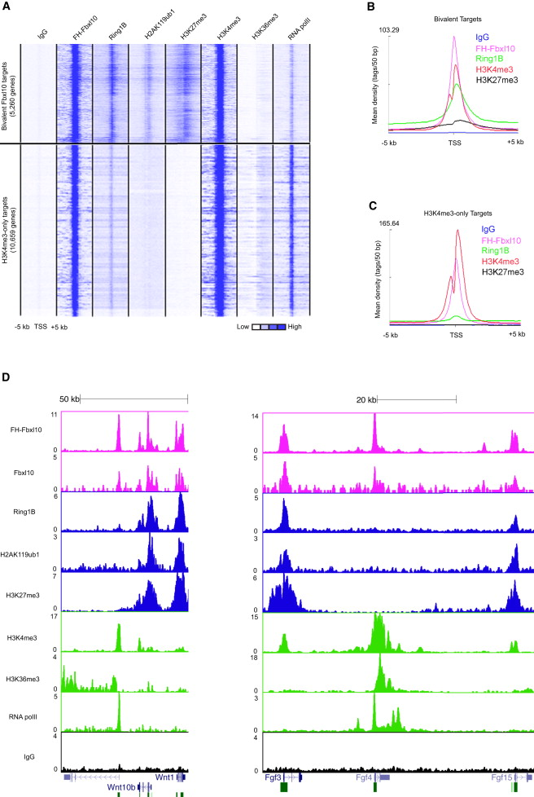
Figure 4. Fbxl10 Colocalizes with Ring1B and H2AK119ub1 on PcG Target Genes but Also Binds to Actively Transcribed Genes(A) Heatmap representation of the binding profiles of IgG, FH-Fbxl10, Ring1B (two assays pooled), H2AK119ub1 (Brookes et al., 2012), H3K27me3 (Lienert et al., 2011a), H3K4me3 (Schmitz et al., 2011), H3K36me3 (Marson et al., 2008), and RNA polII (Lienert et al., 2011b) in mouse ESCs at the indicated Fbxl10 target genes (±5 kb around the TSS). The same color scales (white, no enrichment; blue, high enrichment) were used for all data sets.(B and C) Merged profiles show the ChIP-seq signals of IgG, FH-Fbxl10, Ring1B, H3K4me3, and RNA polII around the TSS of bivalent Fbxl10 target genes (B) or active H3K4me3-only Fbxl10 target genes (C). Average enrichment ratios within ±5 kb regions around to the TSS were calculated.(D) Examples of tracks are shown for designated ChIP-seq binding profiles. The normalized number of tags (TPM) for each ChIP-seq is given to the left of each graph.See also Figures S4 and S5.
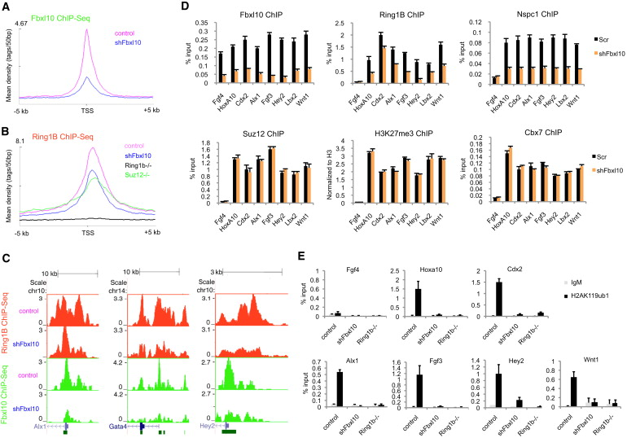
Figure 5. Fbxl10 Is Required for the Recruitment of Ring1B and Nspc1 and Regulates H2AK119 Ubiquitylation of PcG Target Genes(A) Mean distribution of tags for Fbxl10 ChIP-seq in control and Fbxl10 knockdown cells (shFbxl10), confirming the specificity of Fbxl10 ChIP assays. Equal reads (3.3 million) are compared throughout Fbxl10 binding sites in control ESCs.(B) Mean distribution of tags for Ring1B ChIP-seq in control, Suz12^{−/−}, shFbxl10-expressing, and Ring1b^{−/−} mouse ESCs. Equal reads (5.6 million) are compared throughout Ring1B binding sites in control ESCs. For (A) and (B), the average Fbxl10 or Ring1B binding in 50 bp bins is shown within genomic regions covering ±5 kb of the TSSs.(C) ChIP-seq binding profiles for Fbxl10 and Ring1B in control and Fbxl10-depleted ESCs. The normalized number of tags (TPM) for each ChIP-seq is given to the left of each graph.(D) ChIP-qPCR analyses of Fbxl10, Ring1B, Nspc1, Suz12, H3K27me3, and Cbx7 occupancy on the CpG islands of seven representative Fbxl10-Ring1B cotargets in control and Fbxl10-depleted (shFbxl10) ESCs. H3K27me3 enrichment is normalized to H3 enrichment. Fgf4 was only targeted by Fbxl10 and served as a negative control for other ChIP assays.(E) ChIP-qPCR analyses of H2AK119ub1 in control, Fbxl10-depleted (shFbxl10), and Ring1b^{−/−} ESCs. IgM antibody was used as a negative control.The error bars denote SD; n = 3. See also Figure S6.
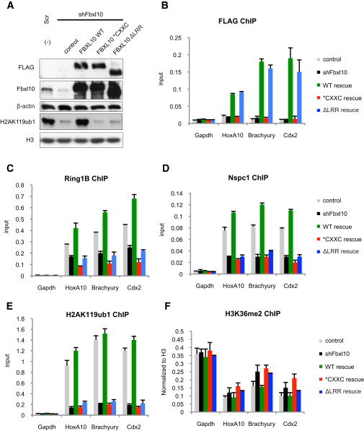
Figure 6. The CXXC Domain of Fbxl10 Is Required for DNA Binding of the PRC1-Fbxl10 Complex, Whereas the C Terminus Is Required for Reconstitution of the Catalytically Active Complex(A) WB analysis of protein lysates and histone extracts prepared from cells transfected with the indicated expression constructs, using antibodies for the indicated proteins.(B) FLAG ChIP-qPCR analyses were performed in the designated ESCs.(C–F) ChIP-qPCR analyses for Ring1B (C), Nspc1 (D), H2AK119ub1 (E), and H3K36me2 (F) were performed in the indicated ESCs. H3K36me2 enrichment is normalized to H3 enrichment. The Gapdh promoter served as a negative control.The error bars denote SD; n = 3.
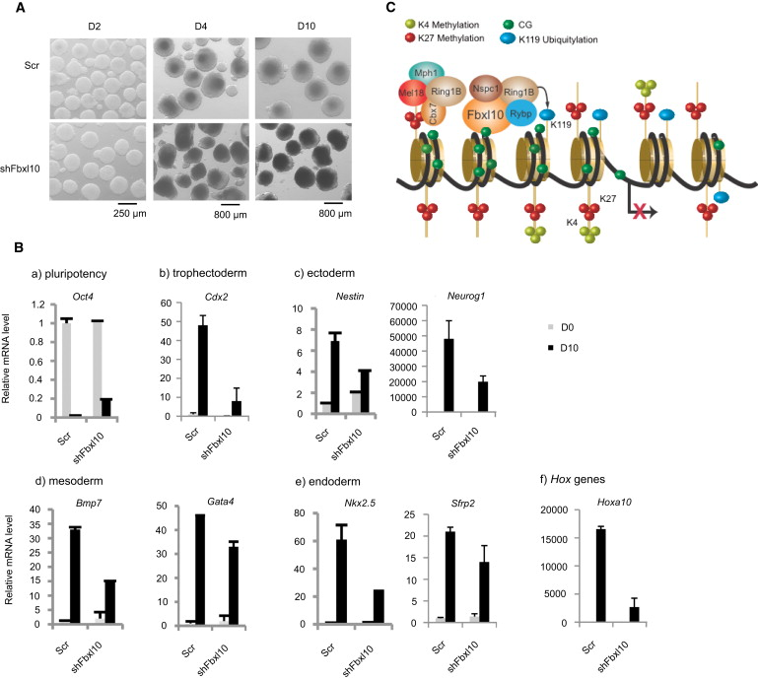
Figure 7. Fbxl10 Is Required for Proper ESC Differentiation(A) EB differentiation of control (Scr) and Fbxl10-depleted (shFbxl10) ESCs. EBs are shown from day 2 (D2), day 4, and day 10 of differentiation.(B) Real-time qPCR analyses of the indicated genes during differentiation of the designated ESCs on the indicated days of differentiation. The error bars denote SD; n = 2.(C) Model showing that the PRC1-Fbxl10 complex is recruited by CpG-rich DNA sequences and mediates H2AK119b ubiquitylation independent of PRC2 (see the main text for a detailed description).See also Figure S7.
Note to users: Corrected proofs are Articles in Press that contain the authors' corrections. Final citation details, e.g., volume/issue number, publication year and page numbers, still need to be added and the text might change before final publication.
Although corrected proofs do not have all bibliographic details available yet, they can already be cited using the year of online publication and the DOI , as follows: author(s), article title, journal (year), DOI. Please consult the journal's reference style for the exact appearance of these elements, abbreviation of journal names and use of punctuation.
When the final article is assigned to an issue of the journal, the Article in Press version will be removed and the final version will appear in the associated published issue of the journal. The date the article was first made available online will be carried over.

Bibliographic information

Citing and related articles

Related articles

  - Chromatin plasticity and genome organization in pluripotent embryonic stem cells
  - 2010, Current Opinion in Cell Biology
  - Show more information

  - A “Complex” Issue: Deciphering the Role of Variant PRC1 in ESCs
  - 2013, Cell Stem Cell
  - Show more information

  - RYBP and Cbx7 Define Specific Biological Functions of Polycomb Complexes in Mouse Embryonic Stem Cells
  - 2013, Cell Reports
  - Show more information

